Study Material
<Program Code: CO/CM/CW/DE/EJ/ET/EN/EX/EQ/IE/IS/IC/MU>: <Course Code:22320><Course Name: Digital Techniques><Topic Name: Number Systems and code>
<UO1b.1.><study Material>

Course Expert: Mrs Rita Vora | Date: 11/07/2020 | Mentor: Mr. K. P. Akole  Co-ordinator: Mrs Nirmala Kamble
Key words  Binary Addition, Binary  Subtraction, Binary Multiplication, Binary Division. | Learning Objective:.  To perform binary arithmetic operations: Binary Addition, Subtraction, Multiplication and Division | Rules :  Binary Addition  0 + 0 = 0  0 + 1 = 1  1 + 0 = 1  1 + 1 = Sum = 0, Carry = 1  Binary Subtraction  0 - 0 = 0  0 - 1 = Diff = 1,Borrow = 1  1 - 0 = 1  Binary Multiplication  0 x 0 =0  0 x 1 =0  1 x 0 =0  1 x 1 = 1  Binary Division  Long division process(same as decimal division).
Key Questions  Do You know the rules for binary addition and binary subtraction?  Do you know the rules of binary multiplication? | Concept Map  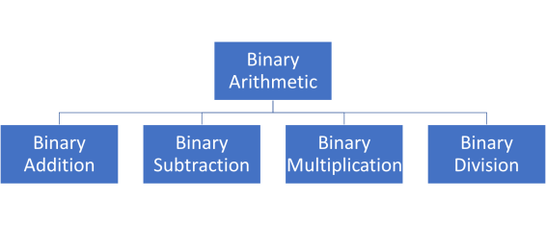
 | Binary arithmetic:  Binary arithmetic is essential part of all the digital computers and many other digital system  The arithmetic operations such as addition, subtraction, multiplication, and division are performed in binary number systems. | Key Definitions  Binary arithmetic:  The arithmetic operations such as addition, subtraction, multiplication, and division are performed in binary number systems.
Solved word Problem

Perform the following binary operation:
1) (110)₂ +(001)₂

1 1 0
+ 0 0 1
1 1 1

2) (110)₂-(010)₂

1 1 0
- 0 1 0
1 0 0

 | Application of Number Systems  - Computers Systems  - Arithmetic Logic Unit  - Adders  - Subtractors  - Digital Systems | Link to YouTube/ OER/ video  http://people.sju.edu/~ggrevera/arch/slides/

Binary arithmetic includes the basic arithmetic operations of addition, subtraction, multiplication and division. Certain rules are to be applied when these operations are performed on binary numbers.
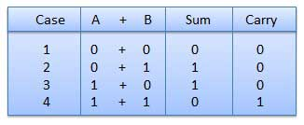
Binary Addition: Binary addition is performed in the same way as addition in the decimal-system and is, in fact, much easier to master. Binary addition obeys the following four basic rules:

In fourth case, a binary addition is creating a sum of (1 + 1 = 10) i.e. 0 is written in the given column and a carry of 1 over to the next column.

Example – Binary Addition

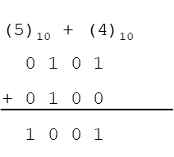
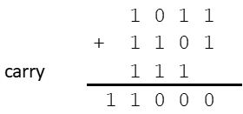
Example 1: (5)₁₀ +(4)₁₀ Example 2: (1011)₂ +(1101)₂

Binary Subtraction
Subtraction and Borrow, these two words will be used very frequently for the binary subtraction. There are four rules of binary subtraction
Case | A - B | Difference | Borrow
1 | 0 - 0 | 0 | 0
2 | 1 - 0 | 1 | 0
3 | 0 - 1 | 1 | 1
4 | 1 - 1 | 0 | 1
When doing subtracting, it is sometimes necessary to borrow from the next higher-order column. The only it will be necessary to borrow is when we try to subtract a 1 from a 0. In this case a 1 is borrowed from the next higher-order column, which leaves a 0 in that column and creates a (10)₂ that is 2 in the column being subtracted. The following examples illustrate binary subtraction.
Examples – Binary subtraction
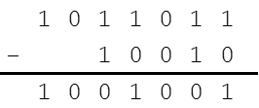
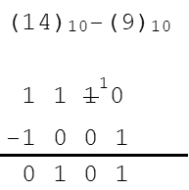
Example 1: (14)₁₀-(9)₁₀ Example 2: (1011011)₂ –(10010)₂

Binary Multiplication
Binary multiplication is similar to decimal multiplication. It is simpler than decimal multiplication because only 0s and 1s are involved. There are four rules of binary multiplication
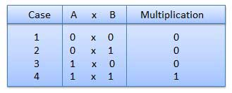

Examples- Binary multiplication
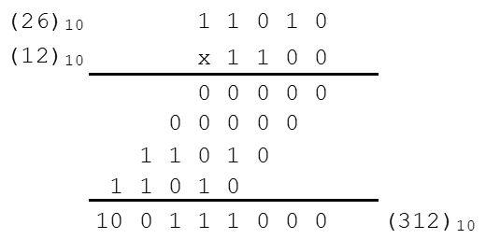
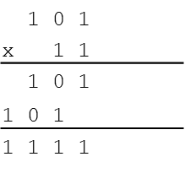
Example 1 : (101)₂ x (11)₂ Example 2: (26)₁₀ x (12)₁₀

Binary Division
Binary division is similar to decimal division. It is called as the long division procedure
Examples-Binary Division
Example 1: (11100)₂ divide by (100)₂ Example 2: (11001)₂ divide by (101)₂
Key Take away

Four Binary arithmetic operations: Binary Addition, Binary Subtraction, Binary Multiplication, Binary Division.
.

